LAB-20: APP DEPLOYMENT USING ECS AND ECR
Name:- Arin Agrawal
SapID:- 500120660
R.No:- R2142230502
Batch:- DevOps - B1
To:- Hitesh Sharma Sir

Phase 1: Prepare and Push to Amazon ECR
ECR is your private library for Docker images.
Create an ECR Repository: In the AWS Console (or via CLI), create a repository named after your app (e.g., my-web-app).
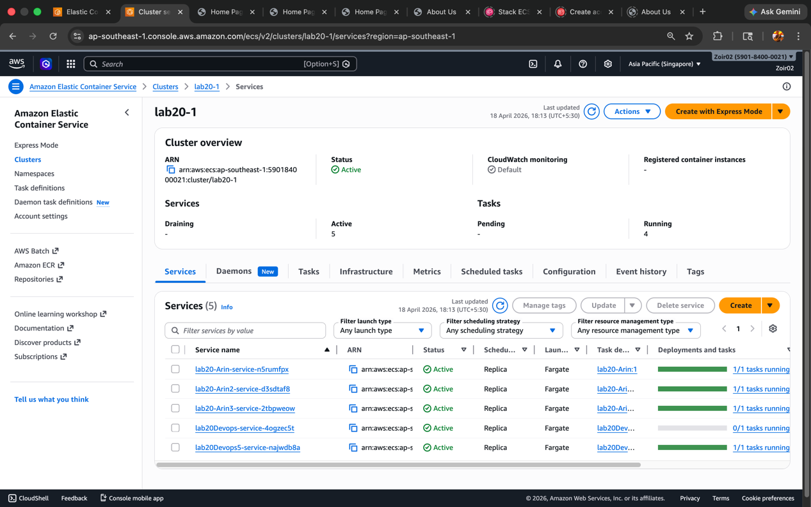
Authenticate Docker to ECR: Run the login command provided by the AWS console (it usually looks like this):
Bash
aws ecr get-login-password --region <your-region> | docker login -username AWS --password-stdin <aws_account_id>.dkr.ecr.<yourregion.amazonaws.com
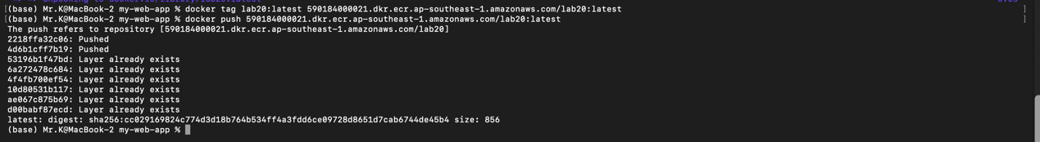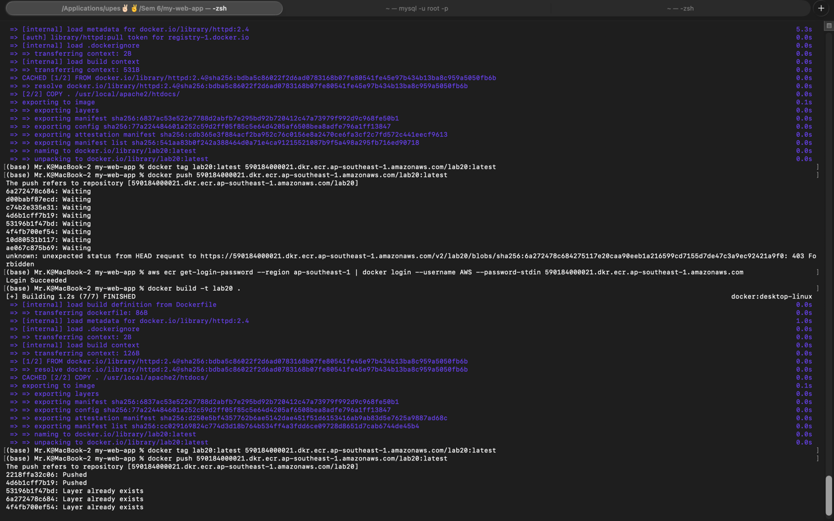
Build and Tag your Image: Build your local Docker image and tag it with the ECR repository URI. Bash docker build -t my-web-app .

docker tag my-web-app:latest <aws_account_id>.dkr.ecr.<yourregion>.amazonaws.com/my-web-app:latest

Push the Image:
Bash
docker push <aws_account_id>.dkr.ecr.<your-region>.amazonaws.com/myweb-app:latest

Phase 2: Set up Amazon ECS
ECS manages where and how your containers run.

1. Create a Cluster
A cluster is a logical grouping of tasks or services. In the ECS console, choose Create Cluster. For most modern apps, select Fargate (Serverless)—this means you don't have to manage underlying EC2 servers.

2. Create a Task Definition
Think of the Task Definition as the "blueprint" for your app.
Launch Type: Fargate.
Container Image: Paste the ECR Image URI you pushed in Phase 1.
Port Mappings: Usually port 80 or 8080 (whatever your app listens on).
Resources: Assign CPU and Memory (e.g., 0.5 vCPU and 1 GB RAM).
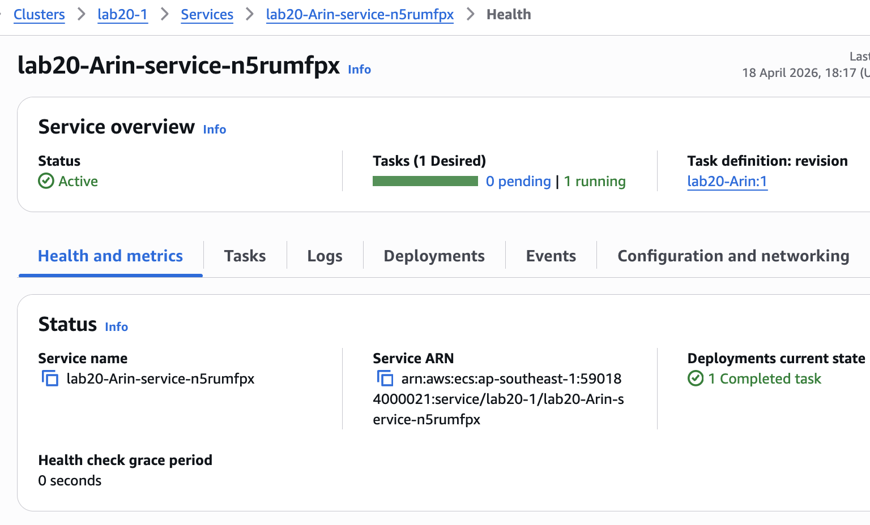

3. Create a Service
A Service tells ECS how many copies of your Task Blueprint to keep running.
Desired Tasks: Set this to 2 or more for high availability.
Load Balancing: (Recommended) Select an Application Load Balancer (ALB). This provides a single URL to access your app and distributes traffic between your running containers.
Networking: Ensure your VPC and Security Groups allow traffic on your application's port.

Phase 3: Access and Update
Verification: Once the service status says "Active" and the tasks are "Running," go to the Load Balancing section to find your DNS Name. Paste that into your browser to see your app.
Updating: To deploy a new version, simply push a new image to ECR with the same tag (or a new one), update the Task Definition with the new image URI, and update the Service to use the latest revision. ECS will automatically perform a Rolling Update, replacing old containers with new ones without downtime.

Quick Comparison: EC2 vs. Fargate
Fargate Launch Type
EC2 Launch Type
You manage the servers
Feature
Management
AWS manages the servers (Serverless)

Feature  Cost  Complexity | EC2 Launch Type  Pay for the instances  High (patching, scaling) | Fargate Launch Type  Pay for CPU/RAM per second  Low (just provide the container)
